TA Reporting Instructions
I. GETTING INTO THE EXCEL GOOGLE DOC
- Go to www.gmail.com
- Login using your username and password:
- Select the App icon followed by “Drive”

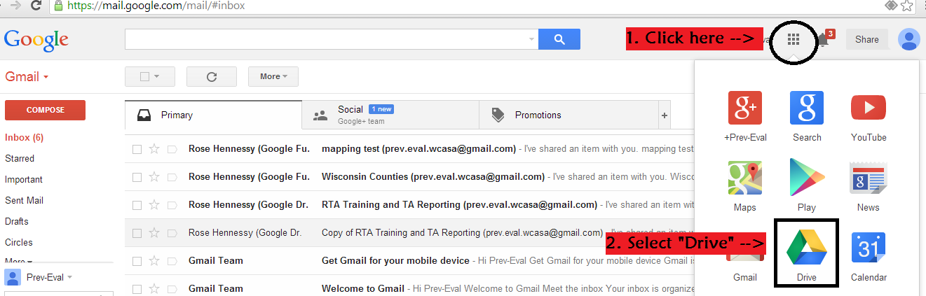

- Select (by clicking on the words): WCASA TA Tracking

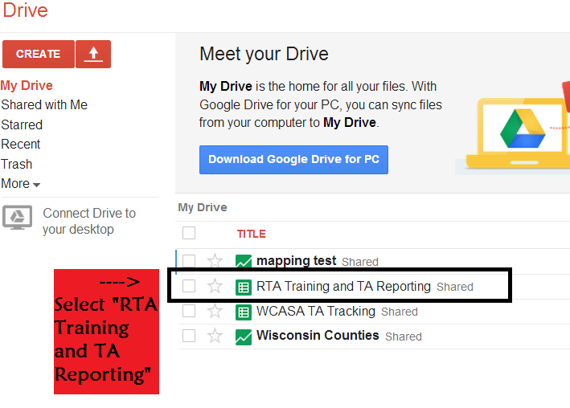

II. NAVIGATING THE DOCUMENT
- There are three things you can do in the document.
  - (1) View notes and definitions / Add questions
  - (2) View and enter regional training meetings, presenters, and attendance
  - (3) Enter your personal TA
- To navigate these items refer to the tabs on the bottom of the screen. The important ones are marked below (see the corresponding color oval below for where to locate each item):
  - (1) Definitions
  - (2) All Trainings
  - (3) Individual region TA reporting sheets.
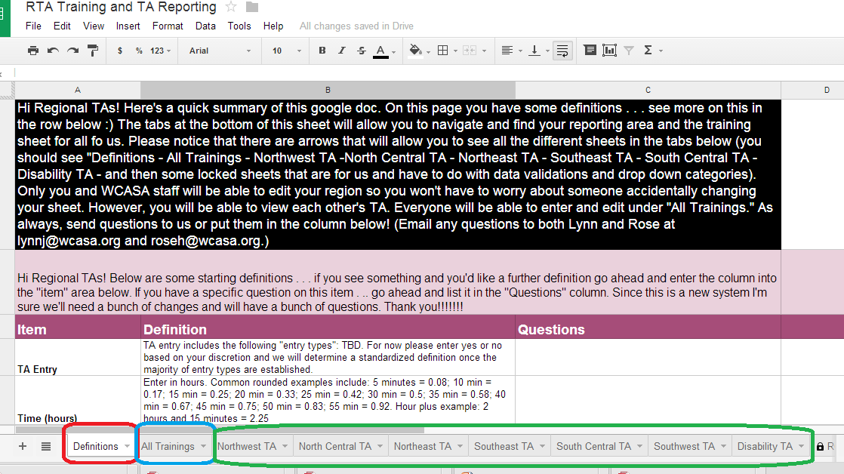

- Click on each tab to view or add information in the excel sheet. You will only be able to edit under your personal TA tab, although you can view all tabs. If you ever have a question or comment please enter it on the “Definitions” page so we can address it as a group and find a solution
IMPORTANT:
- Use existing rows. (Do NOT add new rows or columns.)
- Use “Delete” instead of “Backspace” whenever possible.
III. QUICK TIPS
- How can I see more entry lines?
  - If you would like more space to view your responses you can hide the top horizontal toolbar. Go to the top menu: View Full Menu. To escape back to the previous screen and toolbar, select “Escape” on your keyboard.

- The text is small! How do I make it bigger?
  - You can select the viewing image by holding down the control button “Ctrl” and scrolling on your mouse in or out to increase or decrease the size. Depending on your browser, you can increase or decrease the size of the screen from there as well.

- How can I enter TA without using my mouse?
  - When entering TA, you can use the arrow keys and “tab” to keep from moving back and forth between the mouse and keyboard. Once an option comes up which you’d like to select, instead of typing out the full word you can select “tab” and it will automatically fill for you. If there are different options, you can use the arrow keys to highlight the item and then select tab, or keep writing out the response until it is the only option highlighted.

Examples
    - I want to select “email” as an entry type.
      - I enter “e” and “email” pops up and is selected. Instead of typing out the full word “email” I select tab and move into the next selection.
    - I want to select Family Support Center as the Agency (SASP).
      - I enter “fa” and a number of options pop up. I can use the arrow keys to select “Family Support Center” or keep typing until I get to “Family S” and this is the only option left, then I can select tab.

- My dates are out of order! What should I do?
  - Don’t worry! You can enter the data in whatever order you’d like

